1) how you will manage the bigger databases ?

Ans : a)we will take the Stripped\split backups for the databases to complete it quicker

also b) we will check with the application team to purge the unwanted data

c) we will ensure that all the maintainence jobs( index and update stats) are getting successfull or not.

d) also any table partition is required ?

failover clustering :

where for cluster failover we will restart the roles in cluadmin.msc and we will be having only C drive in

the secondary server and the drives will move to the secondary when we we restart the role in cluadmin.msc and if any drives are missing then we need to check with wintel team

also if any AG roles are there then we need to failover it through the AG from the instance

if any SQL roles and what exactly are those and how to failover those

SQL DBA 2021 Questions :

1) what is encryption and decrytion

Answer : Encryption is used on the physical files to have more security. If we encrypt those backup files then even if some one un-authorized person cannot restore the file because it is encrypted and it will be decrypted using master key file and password. So that the data will be more secure.

2) how to redirect the all the read only requests to all the secondaries ?

Answer : we can suggest the application team to change\add the connection string details accordingly

There is some option of read-only intent in their connection string details

3) Do you face any issues when installing the SQL file.

Answer :

4) when we will suggest Enterprise and Standard ?

Answer : Enterprise : when there is requirement of High availabilites and larger\wider application

Standard : uses for production database of standalone instances.-

5) what is end point ? where it will come like Always on or mirroing ?

Answer : <https://www.youtube.com/watch?v=BF0S8UGJT5o>

5022, 5023 the are communication interfaces , end points should be in start state, incase if not, we will start by using the Alter SET HADR command to start those and please check the command in google and paste here

select * from sys.endpoints

To stop an endpoint:

ALTER ENDPOINT endpoint_name STATE = STOPPED

To start an endpoint:

ALTER ENDPOINT endpoint_name STATE = STARTED

6) What is ACID ? ( are blockings , isolations and these ACID are interrlated) ?

Answer :SQL BOOK 243 but pleas study link it is Very Good.

<https://www.tutorialgateway.org/acid-properties-in-sql-server/>

7)can we add secondary file to datatabase where the DB is in Always on andif yes, will it automatically add in secondary as well ?

Answer : we have to break and then only we can add the secondary file and

even though if we add then it will be out of sync as it will not create the secondary log file of database in secondary servers

8)what is automatic page repair ?

Answer : SQL Server supports automatic page repair for the databases participating in AG configuration. If SQL detects specific corruption errors (Error id 823,824 & 829) for an AG database, SQL Server tries to restore the page from the corresponding replica(primary or secondary).

It works for the following consistency errors.

* **Error 823**: We get this error if the operating system performs a cyclic redundancy check that failed on the data
* **Error 824**: Logical consistency errors such as bad page checksum, torn page detection
* **Error 829**: SQL Server raises error 829 if a page is marked as restore pending
* **Always On Availability Groups:**

[sys.dm_hadr_auto_page_repair (Transact-SQL)](https://docs.microsoft.com/en-us/sql/relational-databases/system-dynamic-management-views/sys-dm-hadr-auto-page-repair-transact-sql?view=sql-server-ver15)

Returns a row for every automatic page-repair attempt on any availability database on an availability replica that is hosted for any availability group by the server instance.

* **Database mirroring:**

[sys.dm_db_mirroring_auto_page_repair (Transact-SQL)](https://docs.microsoft.com/en-us/sql/relational-databases/system-dynamic-management-views/database-mirroring-sys-dm-db-mirroring-auto-page-repair?view=sql-server-ver15)

Returns a row for every automatic page-repair attempt on any mirrored database on the server instance.

9) we will migrate VM’s to other clusters to improve perfomance. So what exactly it will improve ?

Answer : when the network bandwidth is good and based on application users

10)what is Virtual log file ?

Answer : <https://www.sqlshack.com/what-is-sql-server-virtual-log-file-and-how-to-monitor-it/>

VLF : SQL Server internally manages the Log file into multiple smaller chunks called Virtual Log Files or VLFs. A Virtual Log File is a smaller file inside Log file which contains the actual log records which are actively written inside them. New Virtual Log Files are created when the existing ones are already active and new space is required. This brings us to the point where the value of the Virtual Log Files is created. So, whenever there is a crash and recovery condition, SQL Server first needs to read the Virtual Log File. Certainly, if the number of Virtual Log Files is huge then the time taken by the recovery will also be huge which we do not want.

**To Avoid high VLF count : Backing up the Transaction log (or) Shrinking the Transaction log…**

11) what is full recovery and bulk logged difference ?

Answer : when processing bulk transactions (millions of records are inserted) in this bulk recovery model to process the transactions fast and even when these transactions are going we can change it to bulk and again we can change it to full after completion , where BCP Mapping will be done

Data processing will be easier and mainly bcp mapping will be done in Bulk logged recovery model.

There is the **risk of data loss** for these bulk-copy operations because bulk-logging operations prevent recapturing changes on a transaction-by-transaction basis. The point-in-time recovery with the bulk-logged recovery model is not possible because none of the minimally logged operations can be restored.

12) in which file trasactions are truncated log file or tail log ?

Answer : In log file we have both options with truncate and with no truncate but in tail log only with truncate option will be available

13)what exactly tail log is ?

Answer : point in recovery and the tail log backup contains from the last log backup to the latest

15) can we take tail log if DB is corrupted and if can’t what can we do ?

Answer : datafile corrupted means we can take, but if log file corrupted means then we will create one temporarly log file with continue option and we can recover the databse

16) what is automatic seeding in Always on

Answer : This automatic seeding feature is available in Always-on from SQL 2016 version

And this is one of the option available to add the database in to AG Group and it requires that the data and log file paths should be the same on every SQL instance participating under the AG.

This feature is mainly used for larger DB’s like 5 TB and network speed is 1GB\sec

The distance between two sites is 1000 miles

Compression can be used for automatic seeding , but it is disabled by default and we can enable it using DBCC TRACEON(9567, -1)

when db is in big size then we will use this option to add the databse in AG for faster process

Also please check more details in google and write down here

17) what is multisubnet configuration in Always-on ?

Answer : when there are server in two different regions, we need to configure listener with two subnet ip’s ( two subnet ip’s like different 10.66.255.11 and 172.88.111.12)

18) If bussiness ask which HA

Replication – object level and reporting services

Cluster – windows level

Always on and mirroring : Database level but mirroring can have only one secondary

Log shipping : data can be readable in secondary comparing to mirroring

20) what is Recovery Pending ?

Answer : if the SQL Server know that the database recovery needs to be run but something is preventing it form starting, then the server makes the database in Recovery Pending state. This is different from suspect state because it cannot be said that recovery is going to fail

Reasons : Database didn’t shut down properly or sql services started

> user tried to move the log files to a new driveto overcome server performance issue but ended up corrupting the log files in the process

>Database recovery cannot be initiated due to insufficient memory space or disk storage.

Then check the database state

Select name,state_desc from sys.databases then you can check the state and also check the error log if that recovery is in-progress and if not proceed with the below steps if we don’t have backup

First one is : Dettach and Attach the database and check

Second one is : follow the DBCC check db and then do repair allow dataloss.

21) when there are 5 Secondary replicas then how you will apply service packs ?

Answer : First we will apply in Test server and then validate the databases and application

Then we will perform in Production by taking the databases backup and it is not mandatory

And we will perform in Secondary if there is DR (another data center\ different region) we will apply to these servers and validate and then any manual fail over HA servers

And then secondary HA servers and validate and then make primary as secondary and then we will apply to the current secondary and then once completed we can fail over back.

( if still he is asking anything we need to check before applying Service packs means then we will see the MSI \MSP files are missing or exists and if missing down load and execute it.

22) if suppose the primary server crashes and then how secondary made as primary ?

Answer : if it is configured as Automatic failover then automatically secondary will become as primary server

And if it is in manual failover mode.

then we can failover using Cludadmin.msc and also

And also we can make the DB’s using the RESTORE DATABASE AdventureWorks WITH RECOVERY

23) when we are doing the migration of Side by Side or in-place upgrade then apart from the

BOOK what are things we have to consider ?

Answer : in place : db backups and jobs backups and linked servers bacups,logins…etc

We can un install the service pack from control panel if any issue then automaticall it will be in previous Service pack

24) What is tough file in log shipping?

Answer: https://sqlserver-help.com/2014/07/24/sql-server-internals-what-is-tuf-file-in-sql-server/

25) What WRK file? ( Good link for TUF and WRK)

Answer: <https://sqlcodebank.blogspot.com/2013/03/the-tuf-wrk-files-in-log-shipping.html>

If .TUF file is missing\corrupt the log shipping won’t work else we need to configure the secondary server again. (we will receive the error in restote log agent job ) -----

26) What is computer objects and organizational unit?

Answer: An organizational unit (OU) is **a container within a Microsoft Active Directory domain which can hold users, groups and computers**. It is the smallest unit to which an administrator can assign Group Policy settings or account permissions

Where we can create these Active directory for granting the permissions for paricular set of computers like a role.

27) How many temp db files you will create and what you will consider?

Answer: Temp db files depends on the the no of cpu and also increasing the temp db files also depends on number of sessions and usage of temp db

For suppose if there is 20 core CPU then on an average 8 files are recommended

Generally Maximum only 8 datafiles recommended by Microsoft per instance.

If your system has more than 8 logical processors, start with 8 data files and monitor your server’s workload to determine if more data files would be beneficial. If you do find that an increase is warranted, add 4 data files at a time, but do not add more than the number of logical processors.

28) What is Active – Active cluster and Active passive cluster?

Answer: We will install runs different instances in two servers for AA cluster and for AP: We will install install instance only on one server

30) What is stretch database?

Answer: https://www.mssqltips.com/sqlservertip/5526/how-to-setup-and-use-a-sql-server-stretch-database/

32) Restoring mode and standby mode in logshipping why?but in mirroring only Restoring in secondary.

Answer: Secondary log shipped databases can be kept in one of two modes: Restoring - This mode is also known as NORECOVERY mode and cannot be used for read operations. Standby / Read-Only - This mode is also known as STANDBY mode and can be used for read operations

33) what is temp db contention ?

Answer : tempdb metadata contention occurs when many sessions try to access the SQL server temp db’s system tables at the same time during the creations of temp tables. This is heavy workload causes latency on these system tables due to this reason, the query performance will be decreased.

And To resolve that we need to increase the datafiles …….

34) what is temp db version store ?

Answer : <https://www.sqlservercentral.com/articles/tempdb-growth-due-to-version-store-on-alwayson-secondary-server>

It is good to monitor tempdb growth on AlwaysON secondary server because alwaysOn uses tempdb to store row versions and temporary readonly statistics that are created by optimizer on readonly databases

35) when you see databases are in resolving state in always on both primary and secondary how you will fix that ?

Answer : By restarting the SQL services (or) by restarting the AG roles we can fix that if all DB’s are in resolving state

37) Query Tuning ?

Answer : this is the best link <https://www.youtube.com/watch?v=FoTMJFZ4wwg>

6 Query Tuning Techniques - Solve 75% SQL Server Performance Problems (by Amit Bansal)

There are two types of Execution plan

A ) Include actual exectution plan ( where it will execute the query and generate the execution plan

B) Estimated Execution plan ( where it will not execute the query and it will generate the estimation plan)

The basic things we check is for the any missing indexes of warnings when we see the execution plan

Also we have to see Actual number of rows and estimated number of rows should be same and to fix that we can run update stats and index rebuild ( so that if any free spaces will be released and then again execute if still mismatch in rows then it may be because of poor query and we need to find tune it

We need to check from left to right when checking the query plan

Also we should not create the un-necessary indexes where it will create over load to memory

Also check the COST percentage operation in query plan

And also see index scan or index seek is occurring on clustered index then try to fine tune the query for making it index seek to improve the performance

Please watch the above given link for more information and very very useful information

--- We cannot do the online index rebuild in Standard edition (Microsoft blog editions and components

Of Sql server 2016 and 2019)

--- **COPY DATABASE Option :** Best method to move\migrate the larger databases quicker is that use the move database method (attach and dettach) so that no need to backup and restore steps and by copying the data files then you can able to make the db up in destination for attach and dettach method but it requires down time….

also if you use copy database option then it will create package and copied it in destination but the benefit is source server remains online and but the process is slow and used for only small db’s.

----- link for set max memory in SQL server https://docs.centrify.com/Content/reports-topics/ADMemorySQLServerMaxSet.htm

38) What is Query store ?

Answer : <https://www.sqlshack.com/sql-server-query-store-overview/>

---- when the primary and secondary node is set to synchronous then if secondary (or) Primary is down what will happen to synchronous option here ?

Answer : as it is set in Sync the log file will grow due to un commited transactions. so we will remvove the AG else we will get alert messages.

Transaction log : Check with madhu about what happens when a transaction happened , when it will go to buffer manager to log and data file once.

The transaction log contains enough information to undo all changes made to the data file as part of any individual transaction. **The log records the start of a transaction, all the changes considered to be a part of it, and then the final commit or rollback of the transaction**.

---- What are system databases and it’s importance -----

<https://www.vembu.com/blog/system-databases-sql-server/#:~:text=SQL%20Server%20mainly%20contains%20four,is%20the%20most%20important%20database.&text=Master%20Database%20contains%20information%20about%20SQL%20server%20configuration>.

<https://www.mssqltips.com/sqlservertip/1420/sql-server-system-databases/>

The resource database is the fifth, "hidden" database that is a read-only database and contains all system objects of SQL Server. It is used **to make the upgrade process of SQL Server faster and easier**.

--- if last full backup got corrupted then how you will restore and which full and diffs and logs will you restore

And also after the log backup and next log backup the database we need to restore then do we restore with

Tail backup and suppose if log is corrupted then also can we take tail log backup ?

Answer : Page number : 452 from SQL BOOK

--- what exactly we do in security management for servers and databases ?

Answer : encryption and validation of logins and it will be good if they use only windows authentication type.

--------- What is Cutover and what we will do ?

Answer : when migrating what we will do do we use attach and dettach or backup and restore ?and what exactly cutover means. ?

Answer : where we will be having the downtime and all the teams will involve…

--------------DMV's are light weight threads and also

it consumes the less memory compared to DBCC

so DMV's are better compared to DBCC

--- If you are facing any issues in executing the scripts or like unable to create the logins

then check the Triggers sections to see any triggers are enabled.

so please disable the trigger and execute the scripts or create\alter the login and enable the Trigger

---- what is service broker in Sql server ?

--- what are the reason of AG in resolving state ?

Answer : Page NO : 224

---- How the data will transfer from primary to secondary in always on ?

Answer :

---- with respect to installations and migrations do you face any issues ?

Answer :

---- What is SQL Commands and RDBMS.

RDBMS stands for Relational Database Management System. RDBMS is **a program used to maintain a relational database**. RDBMS is the basis for all modern database systems such as MySQL, Microsoft SQL Server, Oracle, and Microsoft Access. RDBMS uses SQL queries to access the data in the database

A relational database management system (RDBMS or just RDB) is **a common type of database that stores data in tables, so it can be used in relation to other stored datasets.**

Answer: 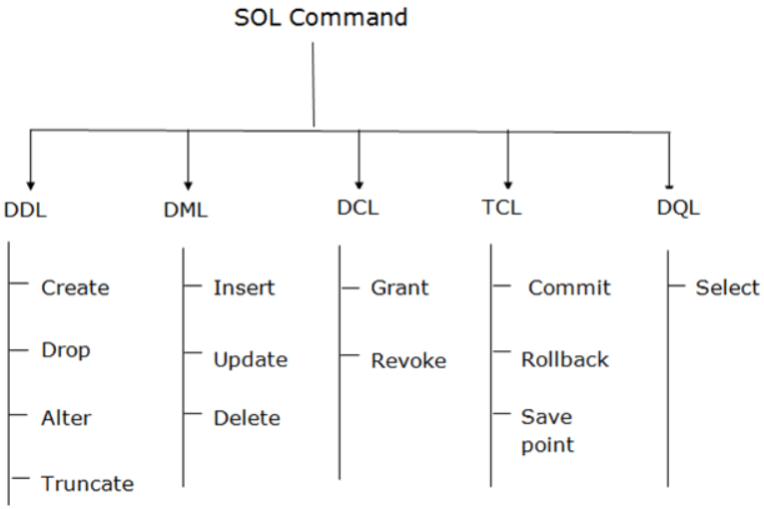

DCL : Data control Language

TCL : Transaction control language

DQL : Data Query language.

--------- what is store procedure and triggers ------------

Answer : A stored procedure is **a prepared SQL code that you can save, so the code can be reused over and over again**. So if you have an SQL query that you write over and over again, save it as a stored procedure, and then just call it to execute it

A trigger is **a special type of stored procedure that automatically runs when an event occurs in the database server.**

**----- We need to configure the index maintainence jobs in both Primary and secondary. When failover happens then the issue appears----**

------ SQL Architecture ?

Select :it will pick from buffer cache(RAM) then show the result , if not it will go to data file

And in temp db it will perform the sort operation as per the required query.

Log file : it will only log the details of transaction basic details.

Update : and it will update in the temp db and it will be there in the buffer cache and once the transaction is completed it will flush it out to the data file.

Log file : it will only log the details of transaction details.

**--------- How can we encrypt the database in Always on ----**

**We cannot add the encryption to existing db in Always-on but we can remove the database from**

**Encrypt the primary database and while adding in GUI then we will get error in adding to AG**

**Then we need to add the master key in master db and certificate in secondary server as well and then**

**And then backup the full and t-log in primary And then add the database in the AG group with T-SQL command**

**And then restore the database with no recovery in secondary and then join the database using T-SQL.**

[**https://www.sqlshack.com/how-to-add-a-tde-encrypted-user-database-to-an-always-on-availability-group/**](https://www.sqlshack.com/how-to-add-a-tde-encrypted-user-database-to-an-always-on-availability-group/)

**---------- Max DOP setting recommendation for on-prem and Azure ---**

[**https://docs.microsoft.com/en-us/sql/database-engine/configure-windows/configure-the-max-degree-of-parallelism-server-configuration-option?view=sql-server-ver16**](https://docs.microsoft.com/en-us/sql/database-engine/configure-windows/configure-the-max-degree-of-parallelism-server-configuration-option?view=sql-server-ver16)

**It doesn’t require restart**

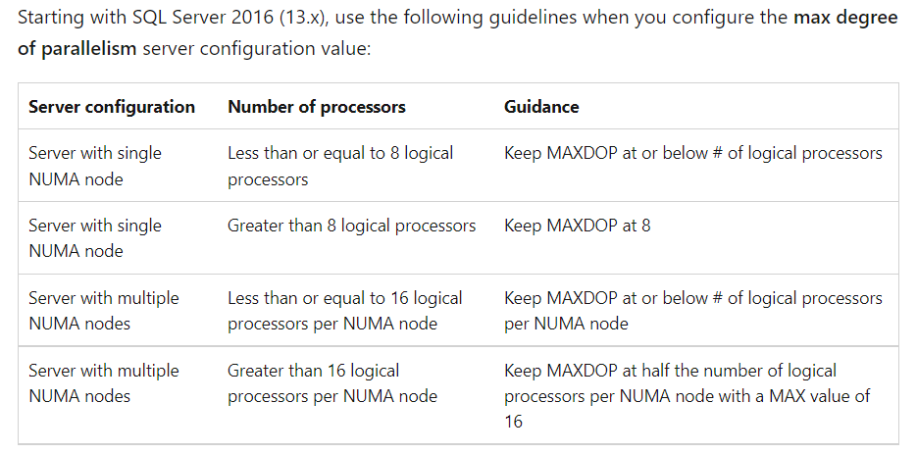

**What is parameter sniffing ?**

Answer : SQL Server creates an optimal plan for a stored procedure by using the parameters that are passed the **first time** to the stored procedure is executed is called Parameter Sniffing.

**How can we handle parameter sniffing issues?**

There are many ways to handle this issue: (2016 version)

* Adding a RECOMPILE option when creating a stored procedure
* Using OPTIMIZE FOR UNKNOWN hint;
* Using OPTIMIZE FOR hint for the particular parameter values
* Using local variables in the stored procedures
* Trace flag 4136;
* Disabling the Parameter Sniffing option of the Database Scoped Configuration

**What is distributed availability group in Always on ?**

Answer : it is introduced in 2016 Version.

A distributed availability group is a special type of availability group that spans two separate availability groups. The availability groups that participate in a distributed availability group do not need to be in the same location. They can be physical, virtual, on-premises, in the public cloud, or anywhere that supports an availability group deployment. This includes cross-domain and even cross-platform - such as between an availability group hosted on Linux and one hosted on Windows. As long as two availability groups can communicate, you can configure a distributed availability group with them.

**What is Redo queue size ?**

Answer : The Availability Group Redo Queue Size (KB) alert indicates the amount of log records from log files in KB that need redoing in the secondary replica to complete synchronization.

To troubleshoot :

We need to check any network latency (or) log backup’s are running fine (or) secondary server is online (or) not.

**Unable to connect to Listener after the failover from primary to DR center, the application is not connecting and listener is also unable to connect.**

Answer : <https://www.sqlshack.com/sql-server-always-on-listeners/> (check from multisubnet in the link ) The Domain Name System (DNS) **turns domain names into IP addresses**

**Joins in SQL server :** [**https://www.youtube.com/watch?v=KTvYHEntvn8**](https://www.youtube.com/watch?v=KTvYHEntvn8)

**Hash and Merge Joins :** <https://www.youtube.com/watch?v=pJWCwfv983Q&t=754s>

## ****Azure Cosmos DB****

Cosmos Database (DB) is a globally distributed, low latency, multi-model database for managing data at large scales. It is a cloud-based NoSQL database offered as a PaaS (Platform as a Service) from Microsoft Azure. It is a highly available, high throughput, reliable database and is often called a serverless database. Cosmos database contains the Azure Document DB and is available everywhere.

<https://intellipaat.com/blog/what-is-azure-cosmos-db/> -- COSMOS DB

NUL Backup : <https://blog.sqlauthority.com/2015/10/26/sql-server-taking-backup-without-consuming-disk-space/>